KUBERNETES – 01
=================================================================================

- Setup Minikube in your local machine.

🔹 Step 1: Verify Docker Installation
checked Docker version:
docker --version
Output:
Docker version 28.5.1
Docker is installed and working
(Minikube will use Docker as the driver)
🔹 Step 2: Create Minikube Directory
created a folder in C drive:
New-Item -Path "C:\" -Name "minikube" -ItemType Directory -Force
Directory created:
C:\minikube
🔹 Step 3: Download Minikube Binary
downloaded minikube.exe:
$ProgressPreference = 'SilentlyContinue'
Invoke-WebRequest -OutFile "c:\minikube\minikube.exe" `
-Uri "https://github.com/kubernetes/minikube/releases/latest/download/minikube-windows-amd64.exe" `
-UseBasicParsing
Now:
C:\minikube\minikube.exe
🔹 Step 4: Add Minikube to System PATH
updated environment variable:
$oldPath = [Environment]::GetEnvironmentVariable("Path", [EnvironmentVariableTarget]::Machine)

if ($oldPath.Split(";") -notcontains "C:\minikube") {
[Environment]::SetEnvironmentVariable("Path", "${oldPath};C:\minikube", [EnvironmentVariableTarget]::Machine)
}
This allows you to run minikube from anywhere.
🔹 Step 5: Verify Minikube Installation
In Git Bash / PowerShell:
minikube version
Output:
minikube version: v1.38.0
Minikube installed successfully
🔹 Step 6: Start Minikube Cluster
started Minikube using Docker driver:
minikube start
From your screenshot:
- Automatically selected Docker driver
- Using container runtime: containerd
- Pulled Kubernetes base image
- Created control-plane node
- Configured CNI
- Enabled addons:
  - storage-provisioner
  - default-storageclass
Cluster successfully started

🔹 Step 7: Verify Minikube Cluster
Check cluster IP:
minikube ip
Output:
192.168.49.2

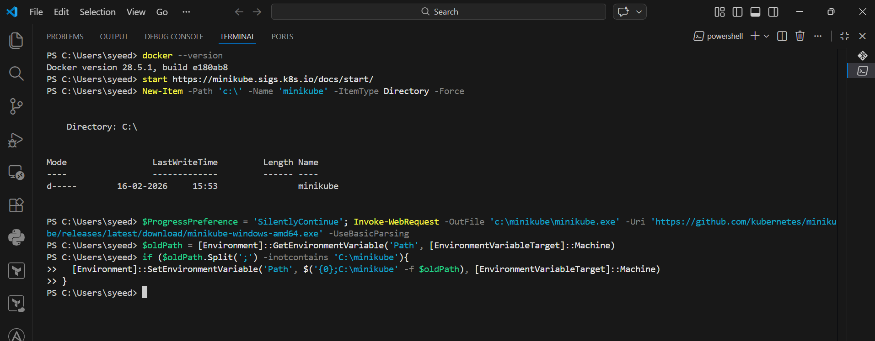

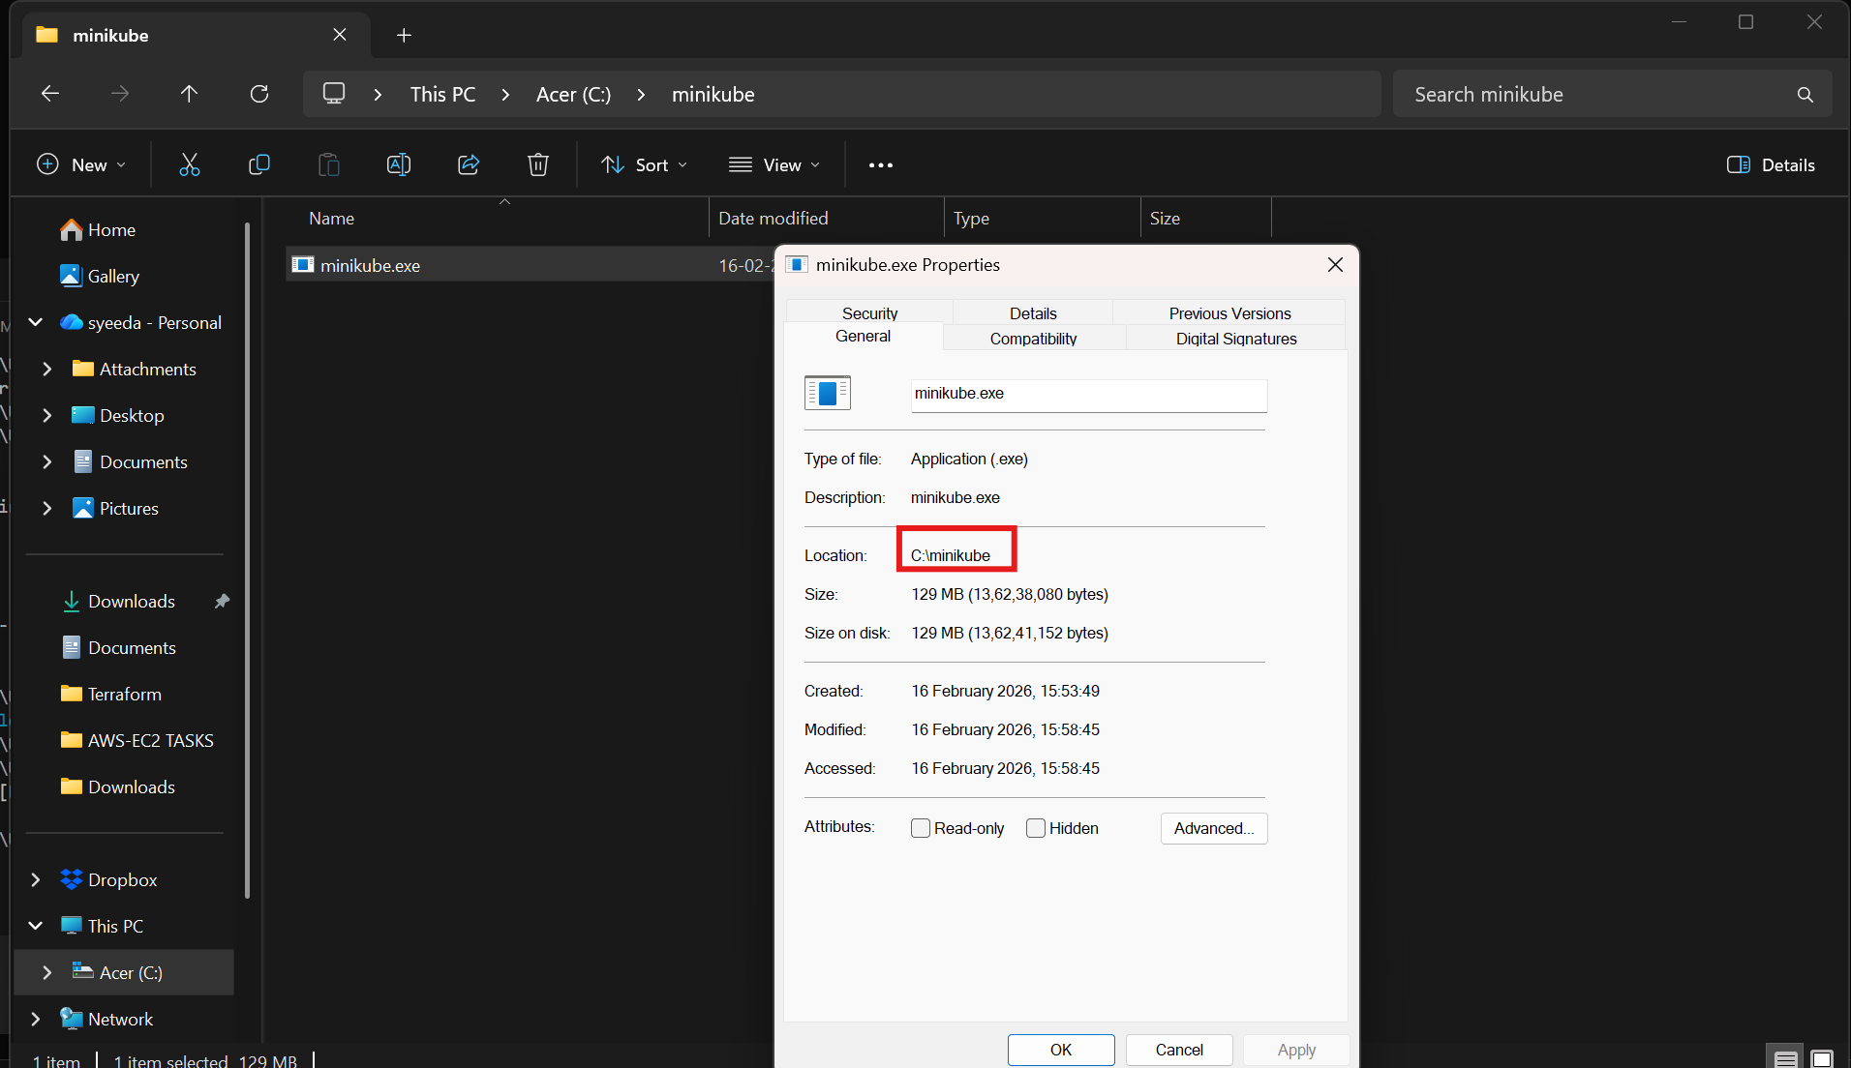

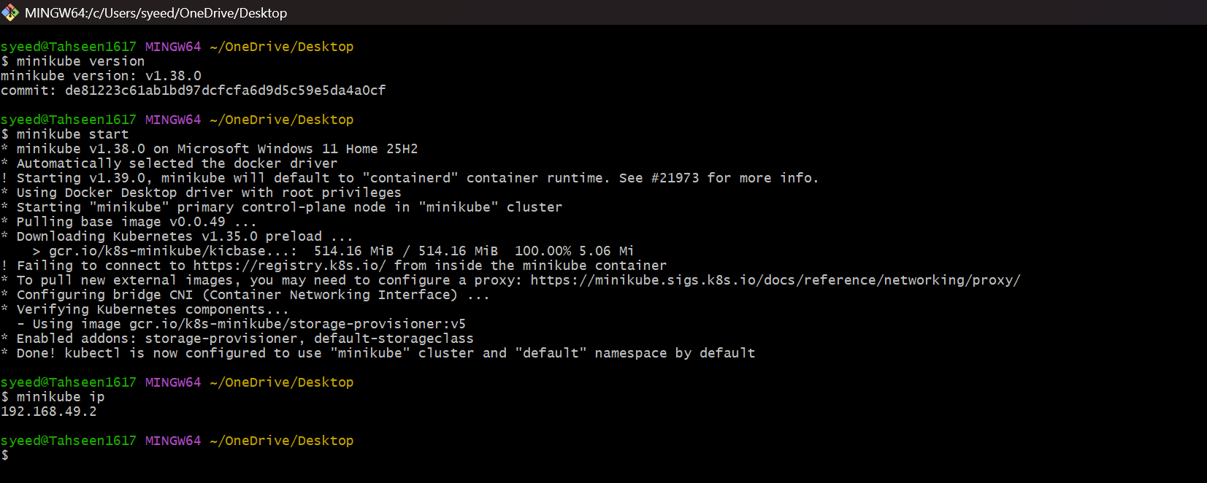

- Setup k8s master and two worker nodes on ubuntu.
🔹 Step 1: Launch EC2 Instances (3 Ubuntu Servers)
You launched:
- k8s-master
- worker-01
- worker-02
Configuration:
- Ubuntu 24.04 LTS
- Same VPC
- Same Security Group
- Multiple AZs
- C7I LARGE
- 20GB storage
- On all nodes sudo swapoff -a

🔹 Step 2: Configure Hostnames (All Nodes)
On Master:
sudo hostnamectl set-hostname k8s-master
On Worker-01:
sudo hostnamectl set-hostname worker01
On Worker-02:
sudo hostnamectl set-hostname worker02

🔹 Step 3: Update /etc/hosts (All Nodes)
added private IP mappings for internal communication.
Example:
sudo vi/etc/hosts
Added:
172.31.37.113 k8s-master
172.31.40.151 worker01
172.31.40.4 worker02

🔹 Step 4: Disable Swap (All Nodes)
sudo swapoff -a
free -h
To make permanent:
sudo sed -i '/ swap / s/^/#/' /etc/fstab

🔹 Step 5: Enable Required Kernel Modules (All Nodes)
Create Kubernetes config:
cat <<EOF | sudo tee /etc/modules-load.d/k8s.conf
overlay
br_netfilter
EOF
Load modules:
sudo modprobe overlay
sudo modprobe br_netfilter

🔹 Step 6: Set Sysctl Parameters (All Nodes)
cat <<EOF | sudo tee /etc/sysctl.d/k8s.conf
net.bridge.bridge-nf-call-iptables = 1
net.bridge.bridge-nf-call-ip6tables = 1
net.ipv4.ip_forward = 1
EOF
Apply without reboot:
sudo sysctl --system

🔹 Step 7: Install Kubernetes Components (All Nodes)
Add Kubernetes Repository:
sudo apt update
sudo apt install -y apt-transport-https ca-certificates curl gpg
sudo mkdir -p /etc/apt/keyrings

curl -fsSL https://pkgs.k8s.io/core:/stable:/v1.29/deb/Release.key | \
sudo gpg --dearmor -o /etc/apt/keyrings/kubernetes-apt-keyring.gpg

echo "deb [signed-by=/etc/apt/keyrings/kubernetes-apt-keyring.gpg] \
https://pkgs.k8s.io/core:/stable:/v1.29/deb/ /" | \
sudo tee /etc/apt/sources.list.d/kubernetes.list
Install Packages:
sudo apt update
sudo apt install -y kubelet kubeadm kubectl
sudo apt-mark hold kubelet kubeadm kubectl
Verify:
kubectl version --client
kubeadm version

🔹 Step 8: Install Container Runtime (All Nodes)
You installed containerd:
sudo apt install -y containerd
sudo mkdir -p /etc/containerd
sudo containerd config default | sudo tee /etc/containerd/config.toml
Enable systemd cgroup:
sudo sed -i 's/SystemdCgroup = false/SystemdCgroup = true/' /etc/containerd/config.toml
Restart & Enable:
sudo systemctl restart containerd
sudo systemctl enable containerd
sudo systemctl status containerd

🔹 Step 9: Initialize Kubernetes Cluster (Master Only)
sudo kubeadm init --pod-network-cidr=192.168.0.0/16
After successful initialization:
mkdir -p $HOME/.kube
sudo cp -i /etc/kubernetes/admin.conf $HOME/.kube/config
sudo chown $(id -u):$(id -g) $HOME/.kube/config
Check:
kubectl get nodes

🔹 Step 10: Install CNI (Calico) – Master Only
kubectl create -f https://raw.githubusercontent.com/projectcalico/calico/v3.26.1/manifests/tigera-operator.yaml
curl -O https://raw.githubusercontent.com/projectcalico/calico/v3.26.1/manifests/custom-resources.yaml
kubectl create -f custom-resources.yaml
Verify:
kubectl get pods -A

🔹 Step 11: Join Worker Nodes to Cluster
On Master:
kubeadm token create --print-join-command
Copy the generated command.

On Worker-01:
sudo kubeadm join 172.31.37.113:6443 \
--token <token> \
--discovery-token-ca-cert-hash sha256:<hash>
On Worker-02:
sudo kubeadm join 172.31.37.113:6443 \
--token <token> \
--discovery-token-ca-cert-hash sha256:<hash>

🔹 Step 12: Verify Cluster
On Master:
kubectl get nodes
Output:
k8s-master Ready
worker01 Ready
worker02 Ready

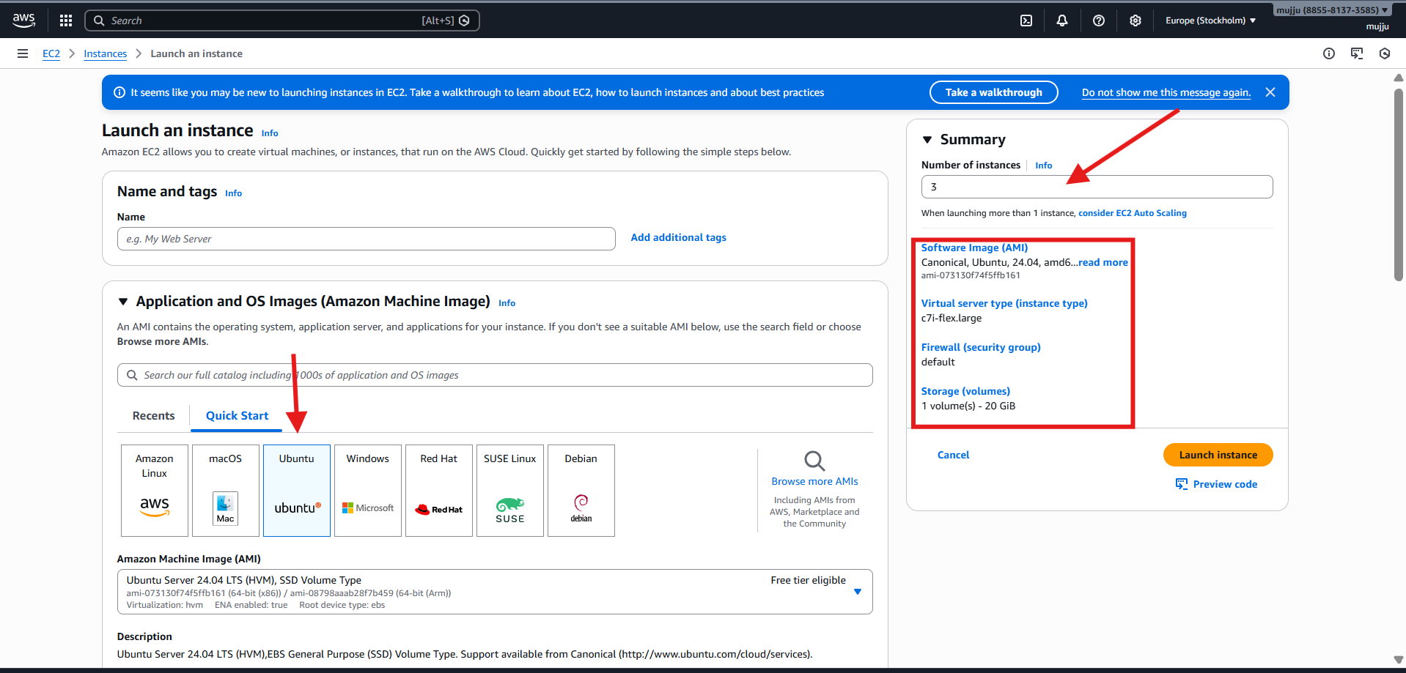

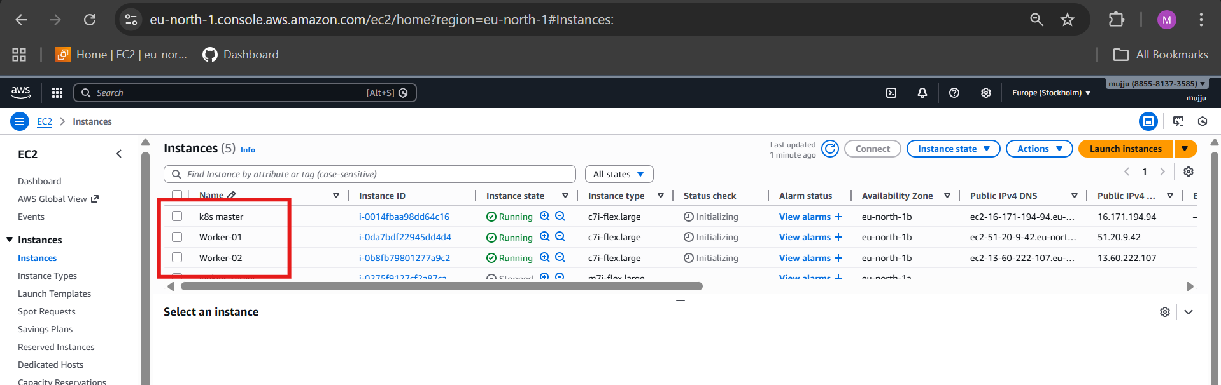

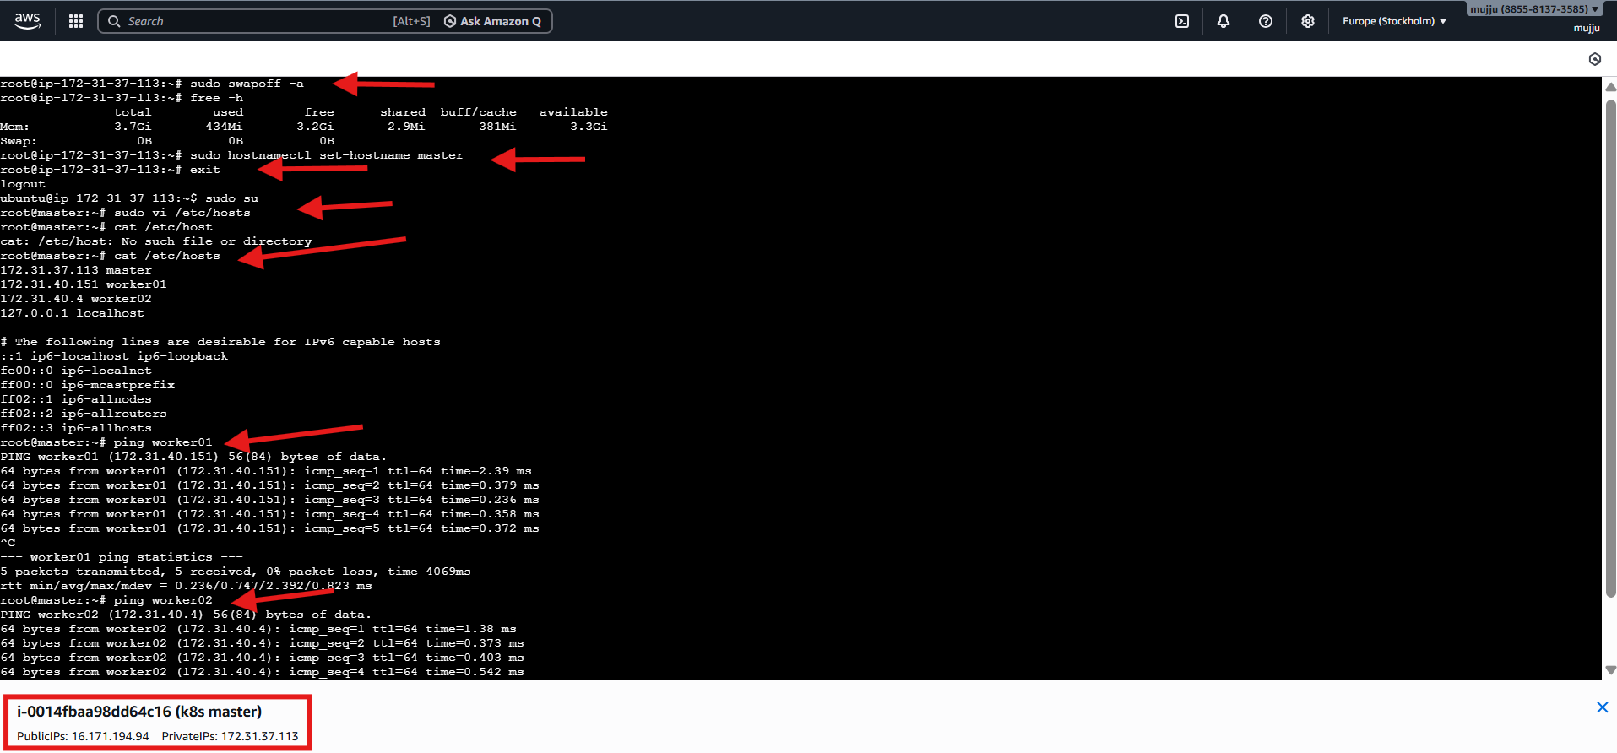

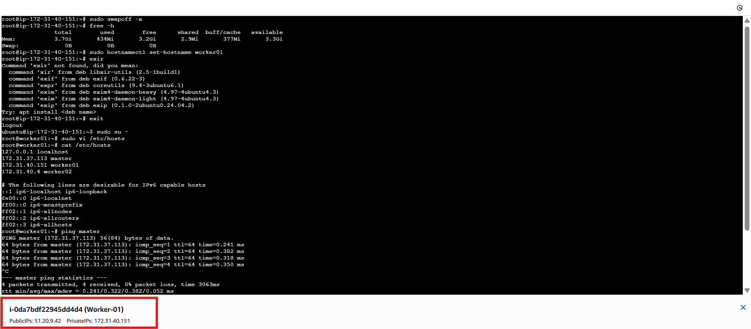

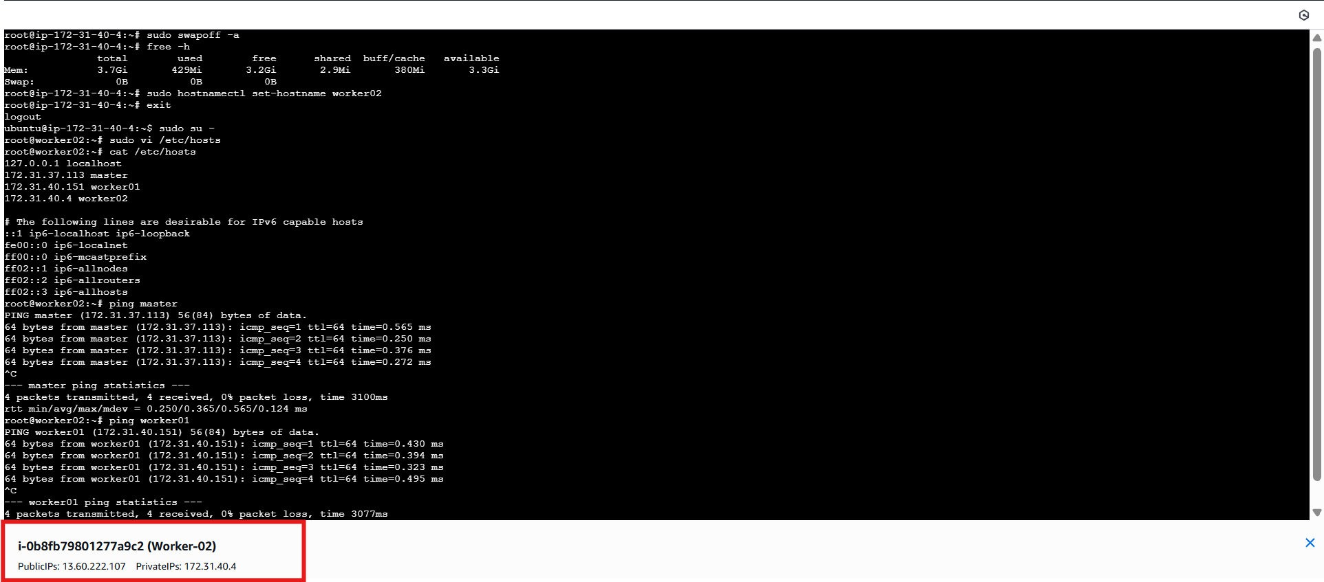

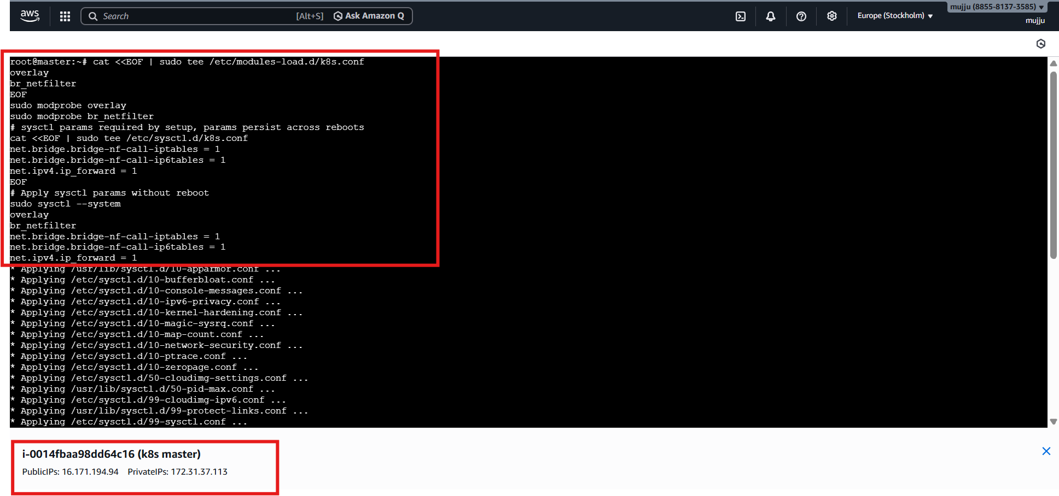

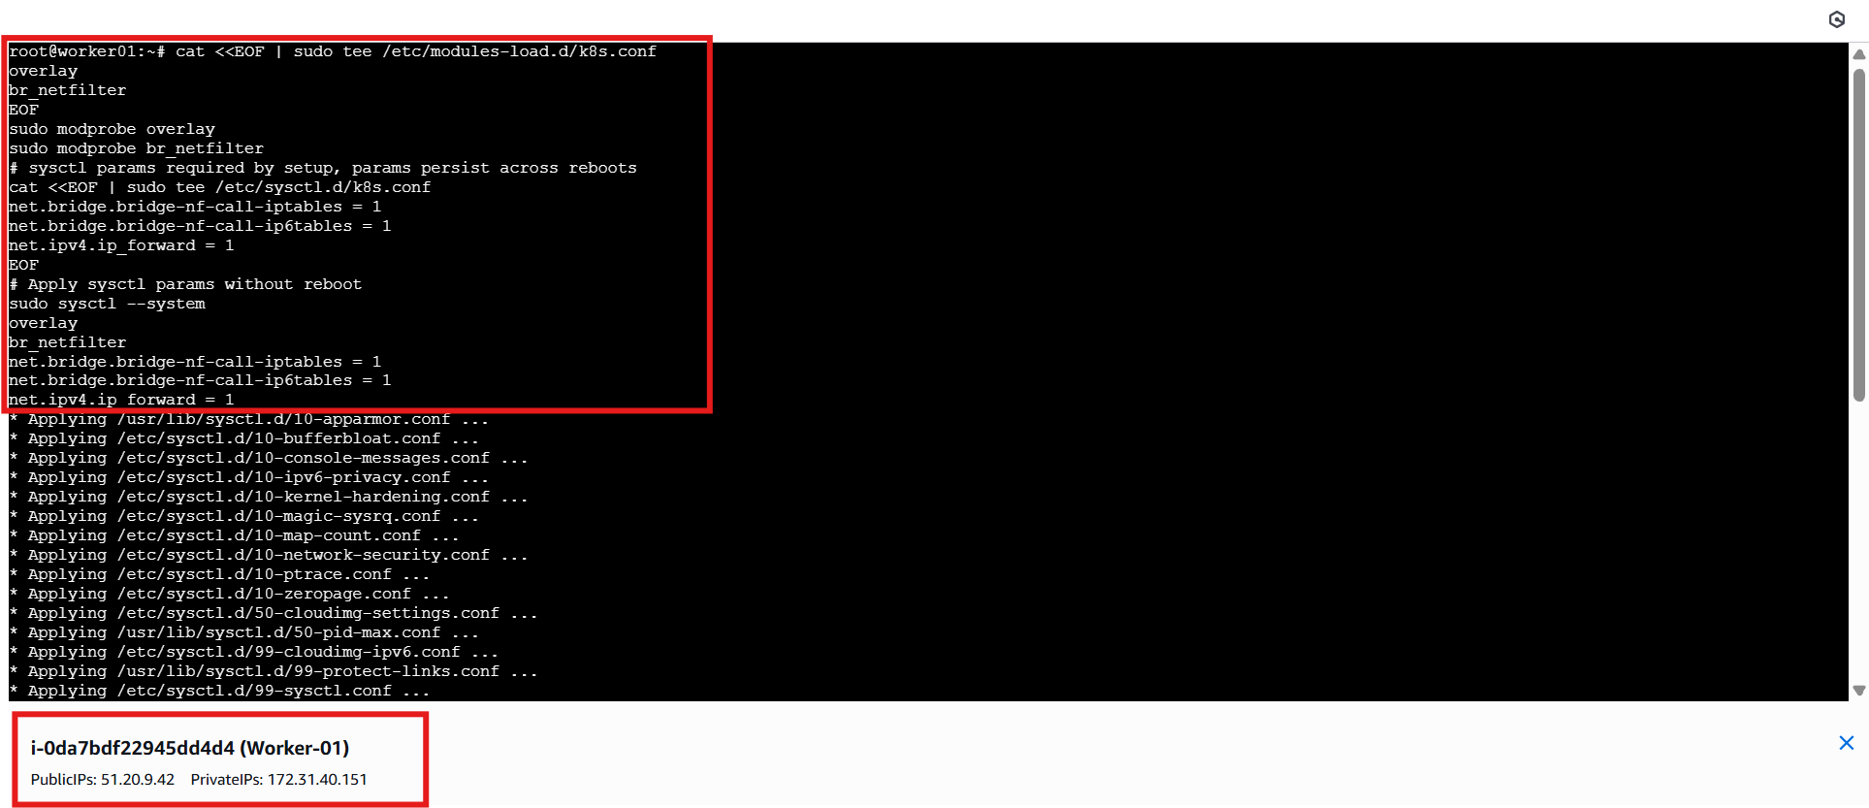

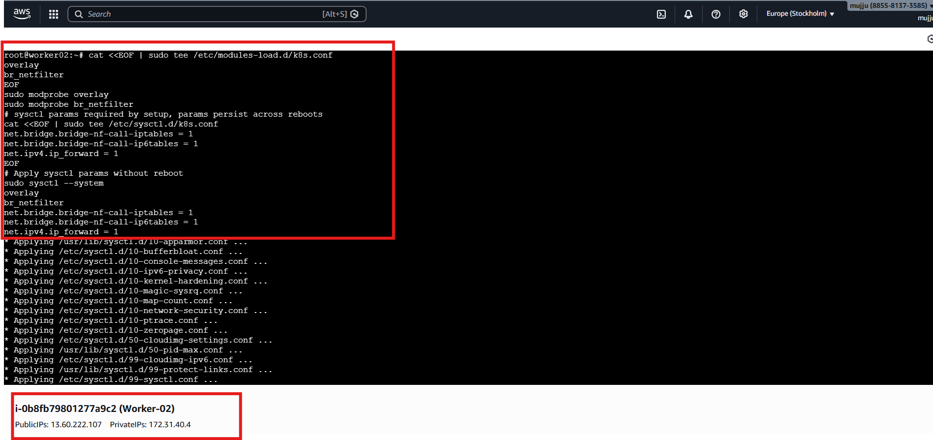

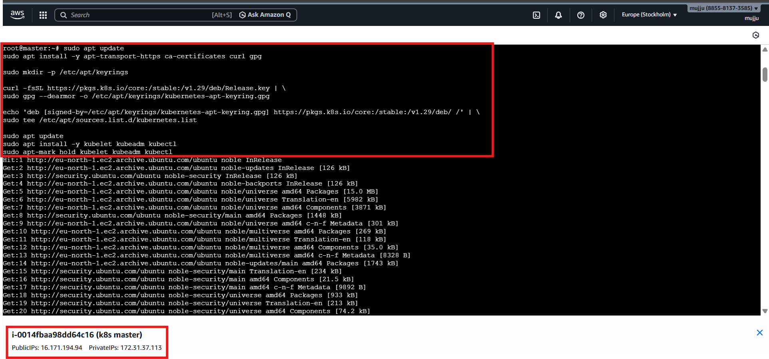

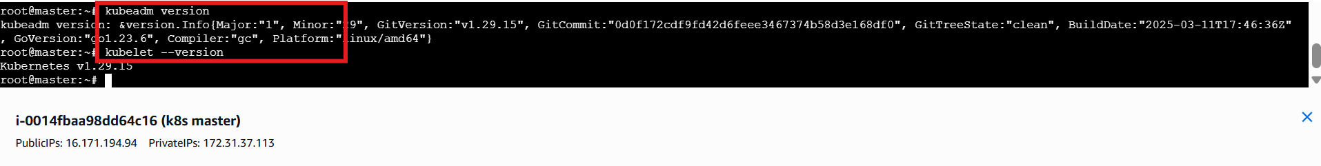
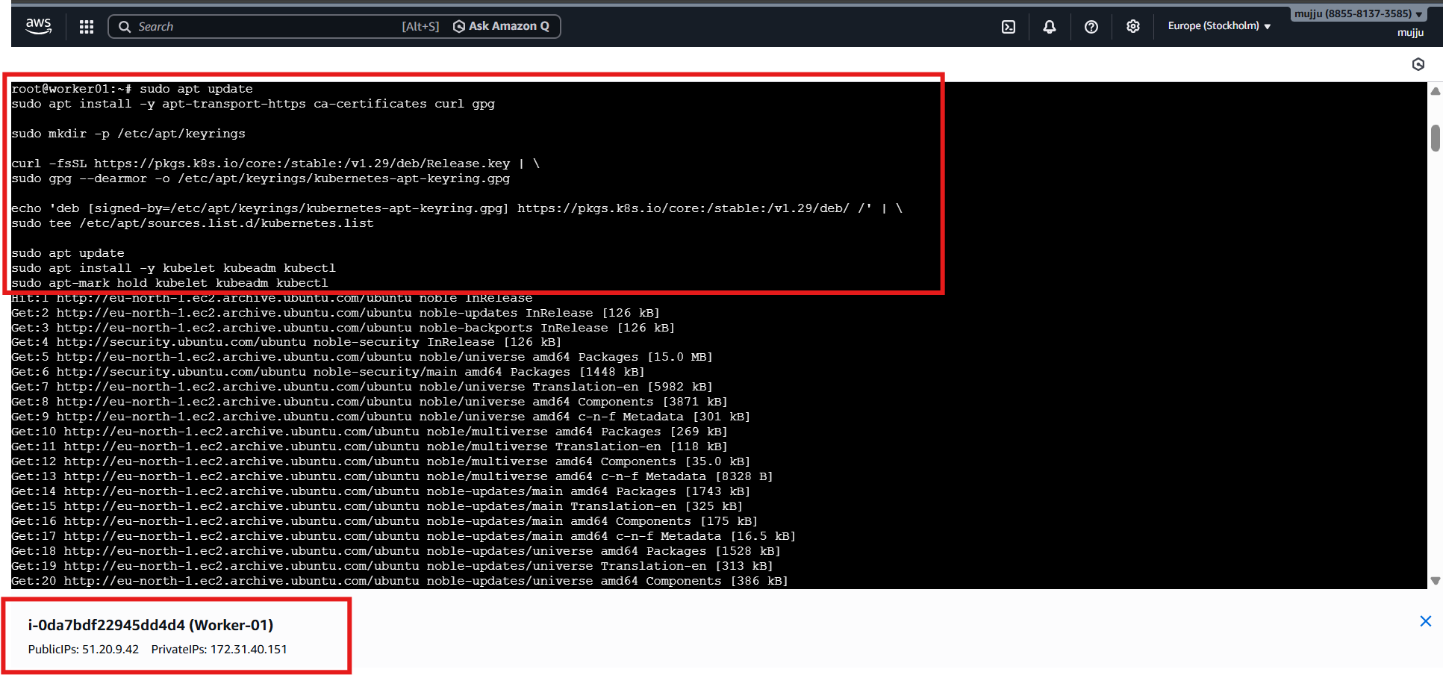

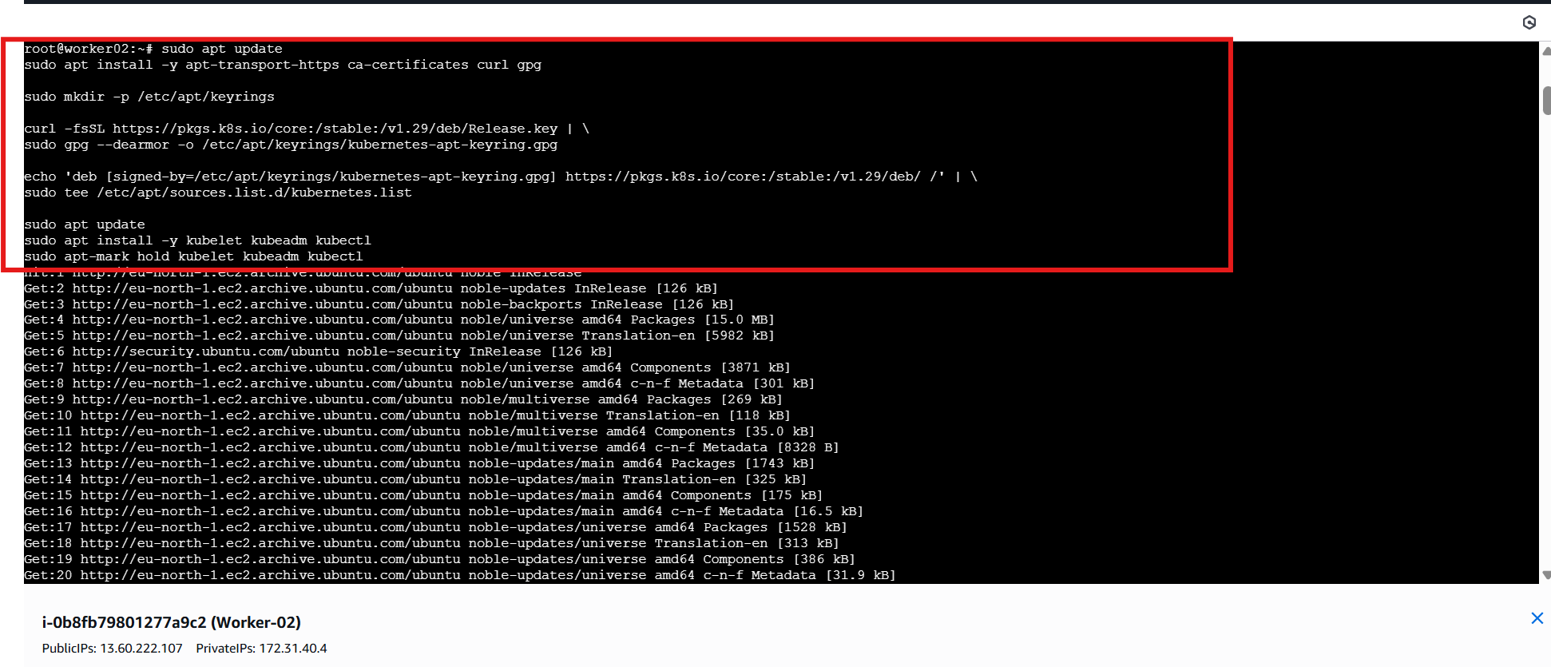
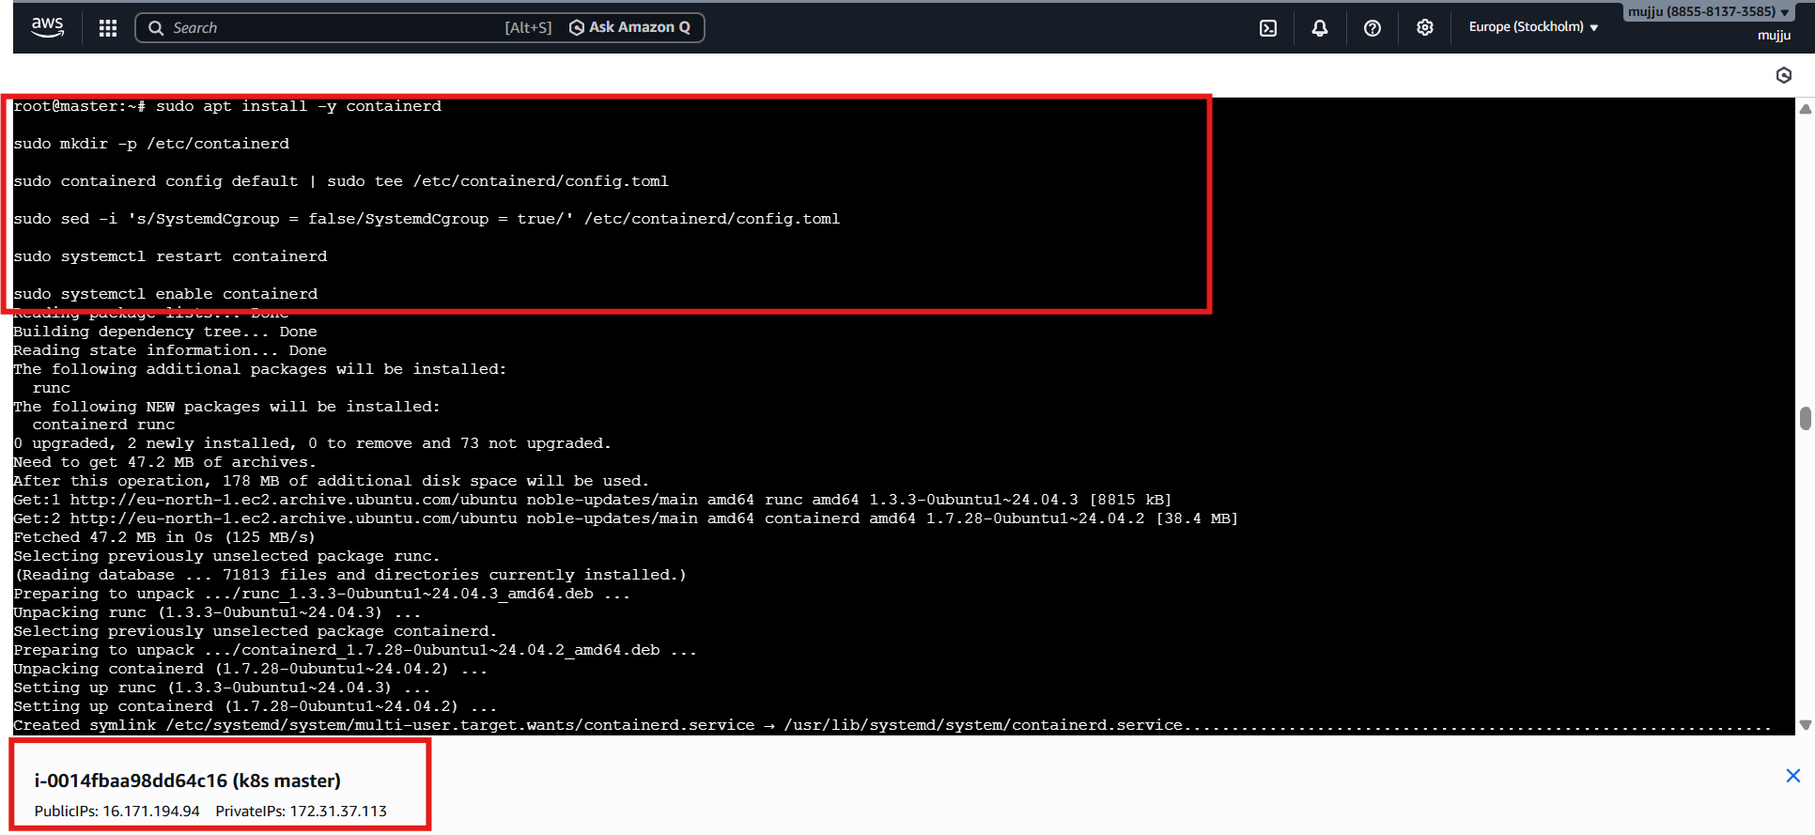

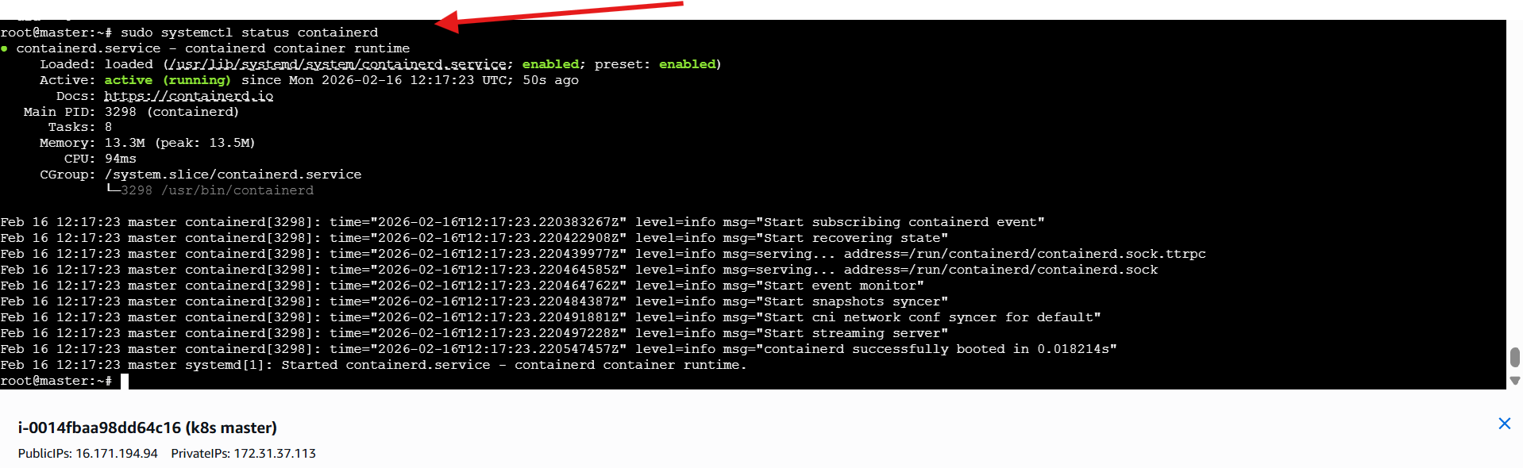

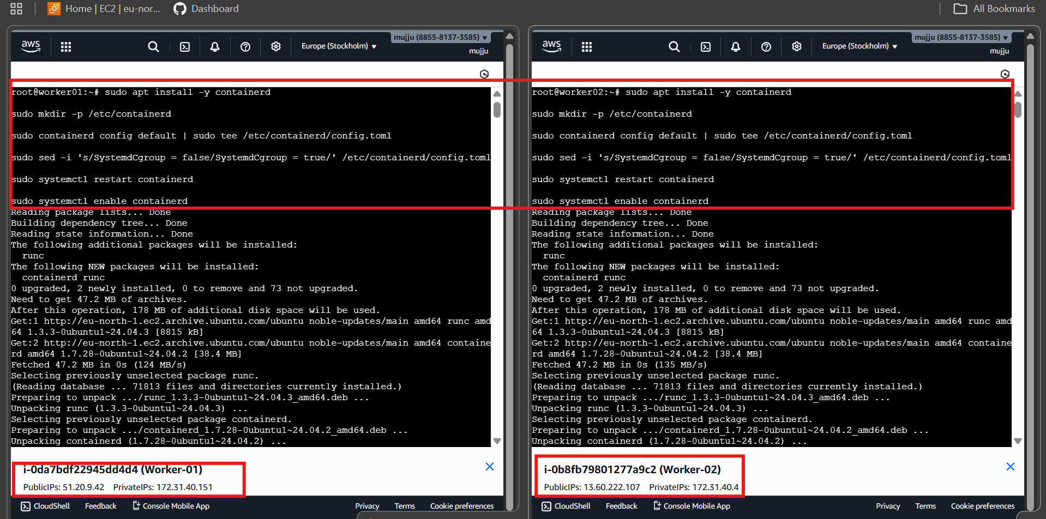
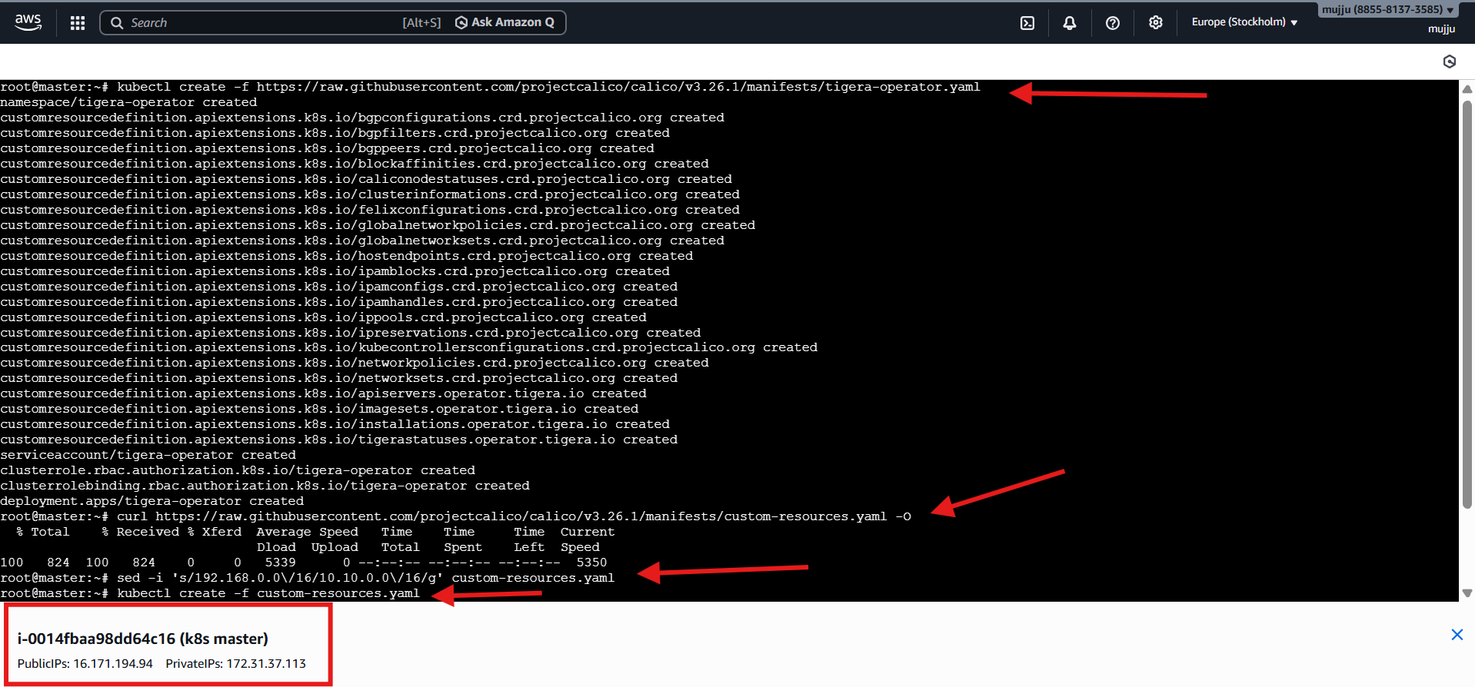

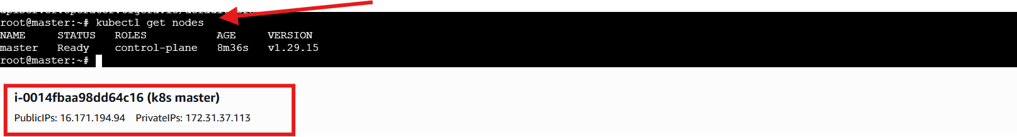

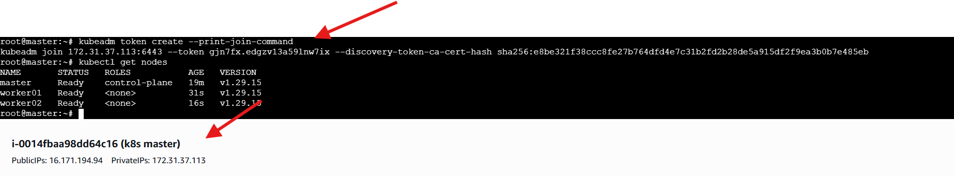

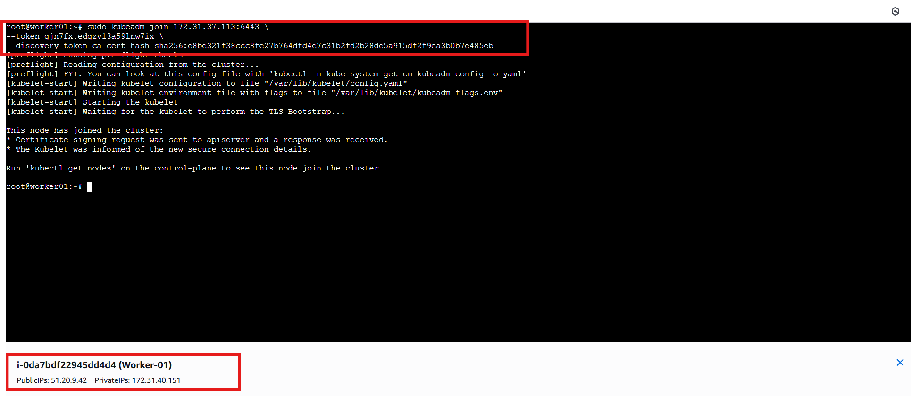

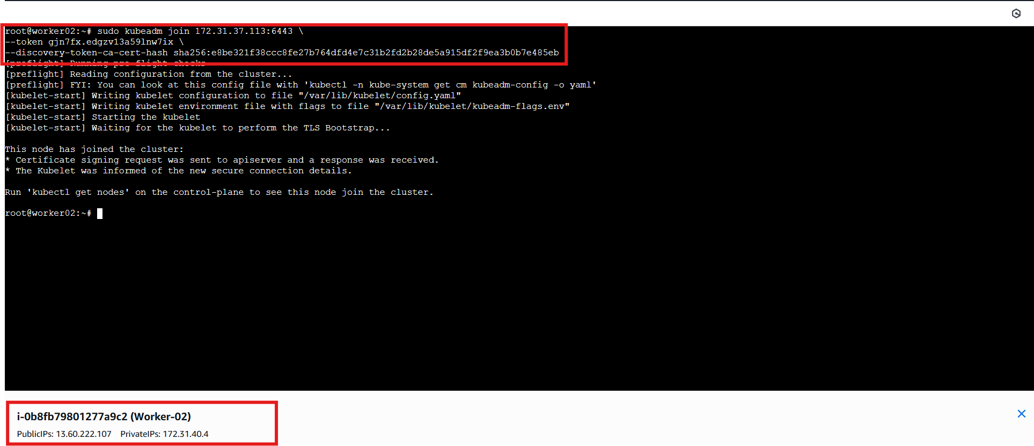

- Run one nginx pod.

Step 1: Create Nginx Pod (From Master Node)

ran:

kubectl run nginx-pod --image=nginx --restart=Never

What This Does:

Creates a pod named nginx-pod

Uses official nginx image from Docker Hub

--restart=Never ensures it creates a Pod (not Deployment)

Step 2: Verify Pod Creation

checked the pod status:

kubectl get pods -o wide

Output showed:

STATUS → Running

Pod IP → 10.10.30.66

Node → worker02

This confirms:

Pod scheduled successfully

Network working (Calico CNI)

Worker node is functional

Step 3: Describe Pod for Detailed Information

ran:

kubectl describe pod nginx-pod
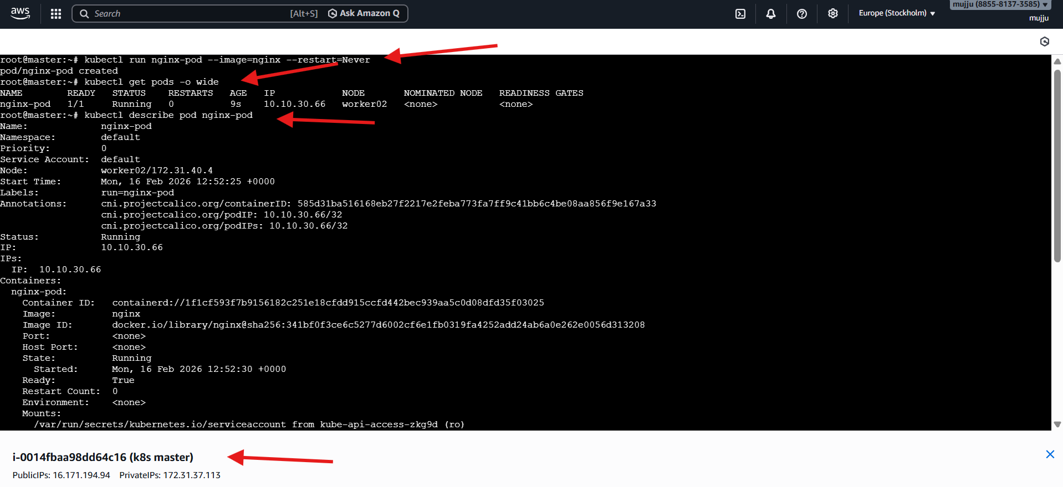
- Mugup Master and slave components on k8s.
1. Control Plane (Master Node)
The control plane manages the entire Kubernetes cluster. It makes scheduling decisions and maintains the desired state.
Components:
1) kube-apiserver
- Entry point of the cluster
- All kubectl commands go through it
- Validates and processes API requests
- Communicates with etcd
2) etcd
- Key-value database
- Stores cluster state
- Stores:
  - Pods
  - Services
  - Secrets
  - ConfigMaps
  - Node information
3) kube-scheduler
- Assigns Pods to worker nodes
- Decides based on:
  - CPU and memory availability
  - Taints and tolerations
  - Node selectors and affinity rules
4) kube-controller-manager
Runs multiple controllers, such as:
- Node Controller
- ReplicaSet Controller
- Deployment Controller
- Job Controller
Ensures actual state matches desired state.

2. Worker Node (Slave Node)
Worker nodes run the application workloads.
Components:
1) kubelet
- Agent running on each worker node
- Receives instructions from control plane
- Ensures containers are running
- Reports node status to control plane
2) kube-proxy
- Handles networking rules
- Maintains iptables rules
- Enables communication between services and pods
3) Container Runtime
- containerd (recommended)
- Responsible for running containers
- Pulls images and starts containers

Architecture Flow
- User runs kubectl command
- Request goes to kube-apiserver
- Scheduler selects a worker node
- kubelet on that node creates the Pod
- Container runtime runs the container

In Your Current Cluster
Master node:
- Runs control plane components:
  - kube-apiserver
  - etcd
  - scheduler
  - controller-manager
Worker nodes:
- Run:
  - kubelet
  - kube-proxy
  - containerd
- Host application Pods

